 | INTERNATIONAL TELECOMMUNICATION UNION
 | RADIOCOMMUNICATION  STUDY GROUPS | Document 6E/349-E  Document 8A/321-E  Document 8B/348-E  Document 9C/115-E
 | RADIOCOMMUNICATION  STUDY GROUPS | 7 March 2006
 | RADIOCOMMUNICATION  STUDY GROUPS | English only
Received: 6 March 2006
High Frequency Co-ordination Conference (HFCC)
wrc-07 agenda item 1.13
Revised HF broadcasting statistics

1 Introduction
This document provides updated statistics and other information concerning the HF broadcasting service which can be used to revise the draft CPM Report for WRC-07.
It also provides general information on the international broadcasting service, the distribution methods used, an outline of the planning criteria used in the HF bands and an indication of how much additional spectrum is required in which bands in order to reduce congestion.

2 Background Information on the International Broadcasting Service
The international broadcasting service has existed for over 70 years. It was initially used to provide news and information to individuals living away from their home country. However, the broadcasting service expanded rapidly to become a means to inform, educate and, to some extent, entertain the general public worldwide. It allows individuals to have access to news and information about other countries that may not be available elsewhere.
It is able to warn individuals about major events that may affect them as well as providing information on relief operations following a natural or man-made disaster.

2.1 Distribution
Frequencies in the HF bands have been used by the broadcasting service for transmissions over long distances since it started over 70 years ago. HF is still an important part of the overall distribution of radio broadcasting services as it allows individuals to listen using a portable receiver whether they are at home, in a car, or in a remote location.
In the last 10 years or so, other forms of distribution, such as internet, satellite and local stations, have become viable and are being used by many broadcasters to supplement their HF coverage. However, although offering advantages in terms of audio quality and availability, there are disadvantages compared to HF distribution that need to be understood:
– Internet, satellite and local stations are dependent on a third party, often referred to as a gatekeeper, to deliver the programme to the listener. It is possible that these forms of delivery can be withdrawn without notice for a variety of reasons;
– Internet and satellite services require more complex receiving equipment than for HF. In many parts of the world, this is likely to be too expensive for the average individual;
– Internet services are less flexible than other forms of distribution as they rely on a connection to internet. At present this is often via cable or limited range wireless connection limiting the options for listening location;
– Local stations, mainly VHF FM, have small coverage areas compared to HF. It is not feasible to cover large areas using FM outlets alone.
The introduction of such additional forms of distribution has allowed broadcasters to reduce their use of the HF bands. However, these additional means of delivery will not replace HF which remains the main distribution method for the international broadcasting service.

2.2 Planning
Unlike many other services, the HF broadcasting service does not have a fixed “Plan” whereby each station is allotted a frequency.
Traditionally, each broadcaster chose the frequencies they wished to use from within the bands authorised by their administration. This process often resulted in broadcasters operating on the same or adjacent channel (±5 kHz) causing mutual interference. Such interference was difficult, if not impossible to resolve quickly. Consequently, a small number of broadcasters coordinated their frequency requirements before each broadcasting season to avoid such mutual interference as far as possible.
This overall unsatisfactory situation led to a proposal at WARC-79 to investigate a new way of planning HF broadcasting services.
Two World Administrative Radio Conferences (WARC’s) were held in the 1980’s to develop an improved Planning system for HF broadcasting. HFBC-84 developed the technical criteria and a new Planning Method. HFBC-87 looked at the results of the test plans prepared by the proposed Planning Method. As the results were not acceptable to administrations, improvements to the Planning Method were agreed. Unfortunately, despite these improvements, further tests demonstrated that it was impossible to accommodate the number of requirements in the HF spectrum available to the broadcasting service. The Planning Method was abandoned in the early 1990’s.

2.3 Informal Coordination
In 1990, short-wave broadcasters from East and West Europe met in Bulgaria with the aim of improving cooperation in HF frequency planning. This was the first meeting of the High Frequency Coordination Conference (HFCC) which continues to meet twice a year to coordinate HF schedules.
As the success of this informal process was recognised, more broadcasters joined and 2 further groups, ASBU and ABU-HFC, were established by the Arab States Broadcasting Union (ASBU) and the Asia Pacific Broadcasting Union (ABU). Membership of HFCC is open to all organisations that provide HF frequency management and planning. Currently, there are around 75 members representing HF broadcasting services via the territory of over 85 administrations within these 3 groups.
Initially, the combined database of requirements was inspected to identify transmissions to the same Ciraf Zone on the same or adjacent (±5 kHz) frequency to identify possible interference problems (referred to as collisions). Over time, a more rigorous technical examination of requirements was developed to identify possible collisions which would then be discussed and, hopefully, resolved between the parties involved. The technical examination uses criteria contained in ITU-R Recommendations. Unlike the proposed Planning System developed in the 1980’s, this technical examination does not consider possible interference from transmissions more than 5 kHz away from the wanted transmission.

2.4 International Regulations
With the abandonment of the Planning Procedure in the early 1990’s there was still a problem with what should replace Article 17 of the ITU Radio Regulations as this Article did not meet the needs of all administrations.
A number of options were considered but the one method that appeared to offer the flexibility required was a combination of the best parts of Article 17, the technical analysis developed for the HFBC Conferences in the 1980’s coupled with the informal coordination process to resolve interference problems. This method was finally adopted at WRC-97 as Article 12.
Article 12 came into force on 1st January 1999 with the first broadcasting season using this new procedure being A99.

2.5 Technical and Operational considerations
The RF channel bandwidth required for a HF broadcasting service is 10 kHz whether using amplitude modulation (AM) or digital modulation (N). Broadcasting services are normally planned to operate on a 10 kHz raster to the same geographic area. Interference from a transmission 10 kHz from a wanted service is ignored unless there is a problem in practice. This is then resolved, if possible, by informal coordination between the parties involved.
However, it is possible to interleave other transmissions to a different geographic area on the 5 kHz points. This interleaving gives rise to adjacent channel interference at ±5 kHz which is taken into account during the informal coordination process.
At peak broadcasting periods in a geographic area, it is common to have transmissions at 5 kHz spacing instead of the usual 10 kHz spacing purely due to the lack of adequate spectrum. This can be seen in Figures 1 and 2. Although the informal coordination process tries to minimise the mutual interference levels, in many cases there are no options other than to accept the level of interference in the expectation that some part of the wanted service area receives an audible service on some days.
Figure 1
Bandscan of 9 500 -9 600 kHz at 1400-1500 UTC at Vienna in B05
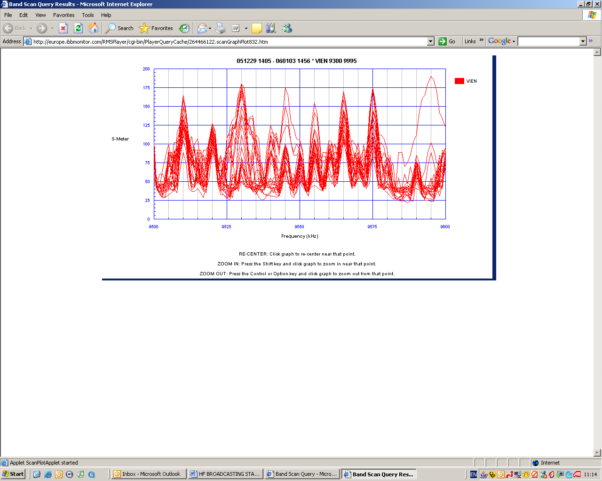
Figure 2
Bandscan of 6 000 -6 150 kHz at 1700-1800 UTC at Vienna in B05
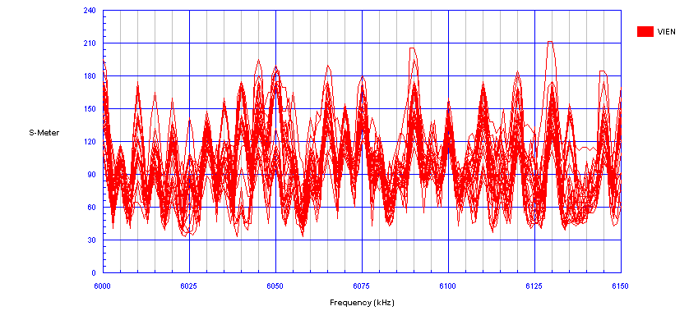
As the broadcasting service has a long history of using the HF bands and monitoring the audibility of transmissions, a great deal of subjective information has been collected. This allows frequency managers to interpret the output of the propagation prediction method (ITU-R Recommendation P 533) such that the planned transmissions have a greater chance of success. Furthermore, with this knowledge, transmissions can be planned to take advantage of known compatible situations between transmissions to improve overall spectrum efficiency. It is common for a single frequency to have multiple simultaneous transmissions to different geographic areas particularly in the lower bands. This simultaneous use is made feasible by the fact that propagation of a frequency varies significantly with time of day. For example, at 6 MHz, the service area tends to be small and close to the transmitter during daylight but is large and at long distances from the transmitter during darkness.
Despite the undoubted improvement in the planning of the HF broadcasting service, there is still a problem with the lack of spectrum to satisfy all requirements, particularly in the lower broadcasting bands.

3 Statistical Analysis
For each broadcasting season, the HF informal coordination groups maintain an up-to-date schedule of requirements submitted by Frequency Management Organisations (FMO’s). These schedules improve in accuracy over time as the FMO’s submit updates to their initial requirements to take account of changes in program requirements and changes due to the ongoing coordination process. Around a month after the start of a broadcasting season, the operational seasonal schedule is published. This schedule has been shown to be more than 95% accurate and has been used for the following statistical analysis.
It should be noted that the combined HFCC/ASBU/ABU-HFC database does not include all requirements for all countries. There are a number of HF broadcasting organizations who are not members of any of these informal coordination groups so do not submit their requirements. In particular, few organizations in Central/South America and Africa submit their requirements while at least one broadcaster in Asia, known to have a significant number of transmissions, is not included. It is not feasible to include these requirements in the database as, although known to be operational, the technical parameters are not known with any accuracy.
Chart 1 shows the total transmitter hours per day submitted to the coordination groups for each season from B00 to B05. This chart shows all requirements for 3 types of HF frequency bands used:
– Bands allocated to the broadcasting service (Inband);
– Bands allocated to the broadcasting service by WARC-92 (WARC-92);
– Any frequencies used that are outside the previous 2 types of band (Out-of-Band (OOB)).
Chart 1
It is apparent that the number of transmitter hours submitted has fallen since the peak in the A03 season. However, there does seem to be a slight increase in the number of transmitter hours submitted for B05 compared to A05.
The following are just some of the factors that contribute to this reduction: -
- Broadcasters reducing the number of simultaneous requirements as the benefits of coordination are realized such that acceptable audibility can be achieved over a larger area with the use of fewer frequencies;
- Broadcasters being encouraged to delete requirements that were planned but did not operate during the season - this is an ongoing activity in HFCC using monitoring to identify such requirements;
- Broadcasters opting to use other forms of delivery (local FM/MF, Satellite and Internet) allowing them to reduce HF transmissions to some parts of the world;
- Broadcasters deciding to close their services using the HF bands;
- Broadcasters reducing transmissions to save money.
Although the overall reduction looks significant at around 15% overall since the A03 season, the reduction is not of the same scale in the lower frequency bands.
Chart 2 shows the number of transmitter hours per day in the bands 4-10 MHz. This chart shows that there is a seasonal variation in the number of transmitter hours coordinated with the highest number in the B seasons (Northern Hemisphere Winter). The difference between A and B seasons is of the order of 10% with the reduction in B-seasons from a peak in B02 to B04 of around 5%.

Chart 2
This demonstrates that the 4-10 MHz bands are still heavily used by the broadcasting service despite the overall reduction in transmitter hours. In fact, more than half the daily transmitter hours fall into the 4-10 MHz band although the amount of available spectrum is significantly less than for the amount of spectrum in the bands above 10 MHz.
Chart 3
Chart 3 shows the percentage of transmitter hours with no co-channel or adjacent channel interference (“clean” hours) in each band between 4-10 MHz for each season. ALL transmissions in the 4-10 MHz band region have been taken into account including those falling in the OOB region. This shows that there has been a small increase in the percentage of clean hours for the 6, 7 and 9 MHz bands since B01 but that congestion is still very severe.
The 4 and 5 MHz bands do not appear to be congested. These bands are predominately for broadcasting in the Tropical Zone and are shared with the Fixed and some Mobile services. As noted earlier, few organizations within the tropical zone actually submit their frequency requirements to the coordination groups so this apparent lack of congestion is misleading.
As there is such a variation in congestion in the bands between 4-10 MHz A to B seasons and over the range from B00 to B05, it is difficult to determine how much spectrum would be required in each band to reduce the level of congestion. Chart 4 shows the average number of clean hours for all seasons considered to date. It should be noted that this includes transmissions in the Inband and WARC-92 bands only.

Chart 4
This clearly shows that the most congested bands are the 6, 7 and 9 MHz bands with less than 60% of transmitter hours free of co- and adjacent channel interference. The most congested band is 7 MHz which has around 50% of transmissions free of either co- or adjacent channel interference.
The level of congestion varies with band type as can be seen in Chart 5. This shows the percentage of clean transmitter hours per band and frequency band type (Inband, WARC-92 and OOB). This demonstrates the reason the WARC-92 bands are already heavily used although not available until 1st April 2007 and why there is a growing use of spectrum outside the bands allocated to the broadcasting service. Very simply put, there is a much higher possibility of a successful transmission on a frequency outside the bands currently allocated to the broadcasting service.
It is anticipated that congestion will increase in these bands as broadcasters have to move to lower frequencies with declining sunspot activity.

Chart 5
In preparing for WRC-03, an estimate of the amount of spectrum in each band required to clear co- and adjacent channel interference was made. This originally analysis was made on the HFCC/ASBU/ABU-HFC database after each coordination meeting. Table 1 gives the equivalent analysis using the average number of transmission hours and collision information across all seasons from B00 to B05. Although there is only 6 years of data, it represents usage across a wide range of sunspot activity compared to the information prepared for WRC-03 which was principally for mid- to high sunspot activity.
At first sight, it may appear that there is an error in Table 1 as the sum of co-channel, adjacent channel collision hours and clean hours is greater than the number of transmitter hours. In practice, it is possible that a transmission with a co-channel collision could also have adjacent collisions.
The present estimate for additional spectrum from Table 1 is now a minimum of 350 kHz to a maximum of 770 kHz. The increase in the minimum amount of additional spectrum is due to the impact of lower sunspot activity and broadcasters needing to use the lower broadcasting bands.
According to Table 1, little additional spectrum appears to be required in the 4 MHz and 5 MHz bands. As explained earlier, this is due to the fact that most broadcasting currently in these bands is in the Tropical Zone and that many of these requirements are generally not submitted to the informal coordination groups. The only band available outside the Tropical Zone for broadcasting in the 4-5 MHz band is 50 kHz (3 950-4 00 kHz) in Region 1 and 100 kHz (3 900-4 000 kHz) in Region 3. The situation in 4 MHz in Region 1 is that there is extreme congestion at low sunspot activity and northern hemisphere winter periods. Experience of using this band suggests that 50 kHz is too small to provide flexibility and efficiency for the transmissions required. Any spectrum allocated to the broadcasting service in the part of the HF band should be a minimum of 100 kHz

Table 1
Collision Statistics and Spectrum Required for Inband and WARC-92 Requirements
Current Inband & WARC-92 Bands Only
HF Broadcast Band (MHz) | Transmitter hours | Mutual Co-channel Collision Hours | Mutual Adj-channel Collision Hours | Satisfied hours |  | Spectrum available (inc. WRC 92 Bands) (kHz) | Additional Spectrum Required To Satisfy Co-channel Requirements (kHz) | Additional Spectrum Required To Satisfy Adj-channel Requirements (kHz) | Percentage Of Satisfied Hours
4 | 70.6 | 1.4 | 2.5 | 67.2 |  | 50 | 1 | 2 | 95.3%
5 | 392.1 | 2.0 | 17.7 | 372.5 |  | 300 | 2 | 14 | 95.0%
6 | 2726.7 | 378.1 | 981.5 | 1609.8 |  | 300 | 70 | 183 | 59.0%
7 | 1970.8 | 497.3 | 786.6 | 977.6 |  | 250 | 127 | 201 | 49.6%
9 | 2909.9 | 474.7 | 1147.6 | 1568.9 |  | 500 | 151 | 366 | 53.9%
Total | 8070.0 | 1353.4 | 2935.8 | 4596.0 |  | 1400 | 352 | 766

The amount of spectrum currently used by the broadcasting service OOB is difficult to determine as transmissions are less densely packed than in the Inband part of the spectrum. The density of transmissions near the edges of the Inband and WARC-92 bands is similar but reduces further from the band edges. Inspection of the HFCC/ASBU/ABU-HFC Operational schedules shows that the main OOB spectrum used for broadcasting are as shown in Table 2.
Table 2
Existing OOB Spectrum currently used for Broadcasting

From (kHz) | To (kHz) | Bandwidth (kHz)
5745 | 5900 | 155
6200 | 6255 | 55
7350 | 7600 | 250
9265 | 9400 | 135
9900 | 9990 | 90
Broadcasting transmissions are therefore spread across an additional 210 kHz at 6 MHz, 250 kHz at 7 MHz and 225 kHz at 9 MHz giving a total of 685 kHz in the bands between 6-10 MHz. The situation in the bands below 6 MHz is rather more complex to analyze due to the Regional nature of the allocations to the broadcasting service together with the lack of full details of current usage in these bands.
As congestion is the OOB region is significantly less than for the other bands, Table 3 is an attempt to identify the amount of spectrum occupied by the OOB transmissions assuming the same density of usage as in the Inband and WARC-92 bands. This suggests that the current equivalent additional spectrum already used by the broadcasting service outside the broadcasting bands is around 300 kHz.
Table 3
Equivalent Spectrum needed to satisfy OOB Requirements

HF Broadcast Band (MHz) | Transmitter hours (Inband) | Transmitter hours (OOB) | Spectrum available (WRC 92 & WRC-03 Bands) (kHz) | Equivalent Spectrum used by OOB Requirements (kHz)
4 | 70.6 | 29.5 | 50 | 21
5 | 392.1 | 103.3 | 300 | 79
6 | 2726.7 | 244.5 | 300 | 27
7 | 1970.8 | 612.1 | 250 | 78
9 | 2909.9 | 539.8 | 500 | 93
Total | 8070.0 | 1529.3 | 1450 | 297

As this spectrum would be as heavily congested as the Inband and WARC-92 band spectrum, a further assessment could be made to determine how much additional spectrum would be required to reduce the congestion in a similar manner. From Table 2 and Table 3, this would be somewhere in the range 300-685 kHz. Adding the results from Table 1 gives a total spectrum requirement for the broadcasting service as somewhere between 650 kHz to 1450 kHz.
Experience of previous attempts at WARC-79, WARC-92 and WRC-03 to resolve various issues in the 4-10 MHz band show that the allocation of this amount of additional spectrum to the broadcasting service will not be feasible as it will have a significant impact on other services.
Ignoring the reduction of congestion in the Inband and WARC-92 Band due to the use of spectrum outside these bands, it would appear that the best attainable solution for the broadcasting service would be an additional allocation of somewhere between 350 kHz to 750 kHz as shown in Table 1. Taking into account the preferred bands identified in Resolution 544, one possible solution could be an allocation of 550 kHz (midway between 350 kHz and 750 kHz) distributed as follows in Table 4: -
Table 4
Possible Additional Allocations to the Broadcasting Service

From (kHz) | To (kHz) | Total kHz
4550 | 4650 | 100
5750 | 5900 | 150
7450 | 7650 | 200
9350 | 9400 | 50
9900 | 9950 | 50
The band 4550-4650 kHz is identified as a possible new band but consideration should also be given to extend the present 4 MHz band in Region 1 by 100 kHz as an alternative.
The band 7450-7650 kHz assumes the situation after 29 March 2009.
It should be noted that from Table 2 that much of this spectrum is already occupied by broadcasting transmissions.

- Proposed Method
In the draft CPM text revised by Working Party 9C, there is one Method to satisfy Issue D. This is:-

5/1.13/11.2 Method [6E/A] (Issue D)
Additional allocation between a minimum of 250 to a maximum of 800 kHz in total to HF broadcasting service in the 4-10 MHz frequency range.
To illustrate this is an example for an additional 350 kHz of spectrum allocated to the broadcasting service.
In developing the CPM text further, it is requested that the broadcasting service need for an additional 550 kHz distributed as indicated in Table 4 is taken into account.
- Transition Period
Use of the lower HF bands is greater at sunspot minimum conditions and particularly during Northern hemisphere winter periods (B – Seasons). Ideally, it would be of greatest benefit to the broadcasting service to have access to any new spectrum allocated at WRC-07 before the next sunspot minimum period.
Chart 9, from NOAA, shows that the next sunspot minimum is likely to be around the beginning of 2007. As it is unrealistic to expect access to any new spectrum immediately, the next option would be prior to the next sunspot minimum period forecast to be around 11 years later in 2018. To ease congestion in the existing bands allocated to the broadcasting service, it would be helpful to allow the broadcasting service access to any new spectrum around 2 years before sunspot minimum when sunspot activity is low. The optimum date for the broadcasting service would therefore be either 27th March 2016 or 30th October 2016.
It is recognized that there should be sufficient time for any service involved in changes to the Table of Allocations to make the necessary changes. The suggested date of 30th October 2016 for implementation is around 9 years after WRC-07. It is thought that this may provide sufficient time to make such changes.
Chart 6
Current Sunspot Cycle from NOAA
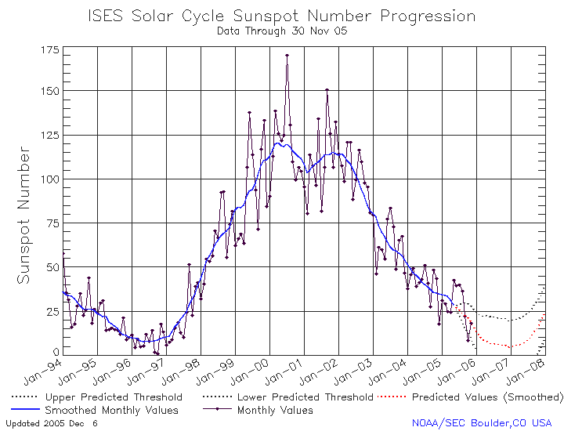

- Regulatory Issues
Any change in the Table of Frequency Allocations will lead to corresponding changes in various parts of the Radio Regulations depending on the conditions for these changes. The following are just some items thought to be helpful and necessary.
  - Sharing / Co-existence
Broadcasters recognize that the HF bands in the range 4-10 MHz are very congested and that the only realistic means of satisfying WRC-07 Agenda Item 1.13 is to consider increased sharing or co-existence between different services. Ideally, any additional spectrum that might be allocated to the broadcasting service should be on an exclusive basis. However, in finding a solution, it may be that some sharing/co-existence with the broadcasting service will have to be considered.
Although it is often considered impossible for other services to share spectrum with the broadcasting service, there are examples of such sharing/co-existence in the ITU Radio Regulations as follows:-
- footnotes which allow services access under certain criteria (low power, national use etc.) on a non-interference basis. The second part of 5.136 is an example of such a footnote.
5.136 The band 5 900-5 950 kHz is allocated, until 1 April 2007, to the fixed service on a primary basis, as well as to the following services: in Region 1 to the land mobile service on a primary basis, in Region 2 to the mobile except aeronautical mobile (R) service on a primary basis, and in Region 3 to the mobile except aeronautical mobile (R) service on a secondary basis, subject to application of the procedure referred to in Resolution 21 (Rev.WRC-95). After 1 April 2007, frequencies in this band may be used by stations in the above-mentioned services, communicating only within the boundary of the country in which they are located, on the condition that harmful interference is not caused to the broadcasting service. When using frequencies for these services, administrations are urged to use the minimum power required and to take account of the seasonal use of frequencies by the broadcasting service published in accordance with the Radio Regulations;
- all bands allocated to the broadcasting service below 6 MHz are on the basis of co-primary with other services.
This sharing/co-existence appears to work as it allows the non-broadcasting services access to spectrum at a time of day in any area when the spectrum is not in use by the broadcasting service. This is particularly true in the 4 MHz band which is not used extensively outside the Tropical Zone by the broadcasting service except during local winter periods at low sunspot activity. Even so, this band tends to be used at peak broadcasting periods equating to local early morning and evening periods.
  - ITU Radio Regulations
Any changes to the Table of Frequency Allocations in Article 5 of the Radio Regulations will require a number of modifications elsewhere in the Radio Regulations. It is suggested that Article 12 should be modified to include any additional spectrum allocated to the broadcasting service on a Primary basis. Any spectrum allocated on a co-primary basis comes under the procedures of Article 11.
____________

Region 1 only

